

**Activity based**

**Project 1 Report on**

**Fundamentals of Data Science**

**Submitted to Vishwakarma University, Pune**

**Under the Initiative of**

**Contemporary Curriculum, Pedagogy, and Practice (C2P2)**

**By**

**Aarya Trifale**

**SRN No : 31241458**

**Roll No : 41**

**Div : F**

**Second Year Engineering**

**Department of Computer Engineering**

**Faculty of Science and Technology**

**Academic Year**

**2024-2025**

**Domain :** **Underwater Acoustics**

**Project Statement /Project Title:** Statement: Analyzing the Impact of Depth on Sound Intensity in Underwater Environments

**Regression**: Predicting Sound Intensity

This regression analysis aims to predict sound intensity based on the depth of water, helping to understand how underwater acoustics vary with depth.

**Project Objective:**

The objective of this project is to analyze underwater sound data to understand the relationship between water depth and sound intensity. By utilizing regression analysis, the goal is to predict sound intensity based on varying depths, contributing to insights in underwater acoustics.

**Project I: details/Project Description:**

This project analyzes underwater sound data to examine how sound intensity changes with water depth. It involves data exploration, visualizations of sound types and their distributions, correlation analysis between depth and intensity, and regression analysis to predict sound intensity based on depth. The findings aim to enhance understanding of underwater acoustics.

Descriptions for each column in the database:

* sound_type: The type of sound detected (e.g., Ship Noise, Seismic Activity, Whale Call).
* location: The geographical location where the sound was recorded (e.g., Indian Ocean, Pacific Ocean).
* time: The timestamp of the sound event, indicating when it was recorded.
* intensity_db: The intensity of the sound in decibels (dB).
* depth_meters: The depth (in meters) at which the sound was detected.
* duration_seconds: The duration of the sound event, measured in seconds.
* frequency_hz: The estimated frequency of the sound (in Hz).
* water_temperature_c: The water temperature (in degrees Celsius) at the depth of the sound detection.
* salinity_psu: The salinity of the water in Practical Salinity Units (PSU).
* distance_from_source_m: The estimated distance (in meters) between the recording device and the sound source.
* ambient_noise_db: The level of ambient noise (in decibels) present during the recording.
* Five lines description about the Dataset

Relative Theory:

This project is grounded in the principles of underwater acoustics, which explain how sound propagates in water. Sound intensity, measured in decibels (dB), is influenced by factors such as water depth, temperature, and salinity.

Linear regression is employed to model the relationship between sound intensity and depth. It allows us to predict sound intensity based on depth measurements, assuming a linear relationship. The correlation coefficient helps assess the strength and direction of this relationship, providing insights into how sound varies with depth in underwater environments.

Implementation and Methodology:

1. **Data Collection**:  
   I worked with a dataset that had information about sound intensity at different water depths, as well as the type of sound recorded.
2. **Data Exploration**:  
   I started by exploring the dataset to understand it better. This included checking the types of sounds and how many data points were available.
3. **Visualizations**:  
   I used scatter plots and histograms to see the relationship between depth and sound intensity, and to visualize the distribution of different sound types.
4. **Correlation Analysis**:  
   I calculated the correlation between depth and sound intensity to see if there was a strong relationship between them.
5. **Regression Analysis**:  
   I used linear regression to predict sound intensity based on the depth of the water. This helped me understand how sound behaves at different depths.
6. **Conclusion**:  
   After completing the analysis, I summarized the findings to gain insights into how sound changes with depth in underwater environments.

**Project Outcome:**

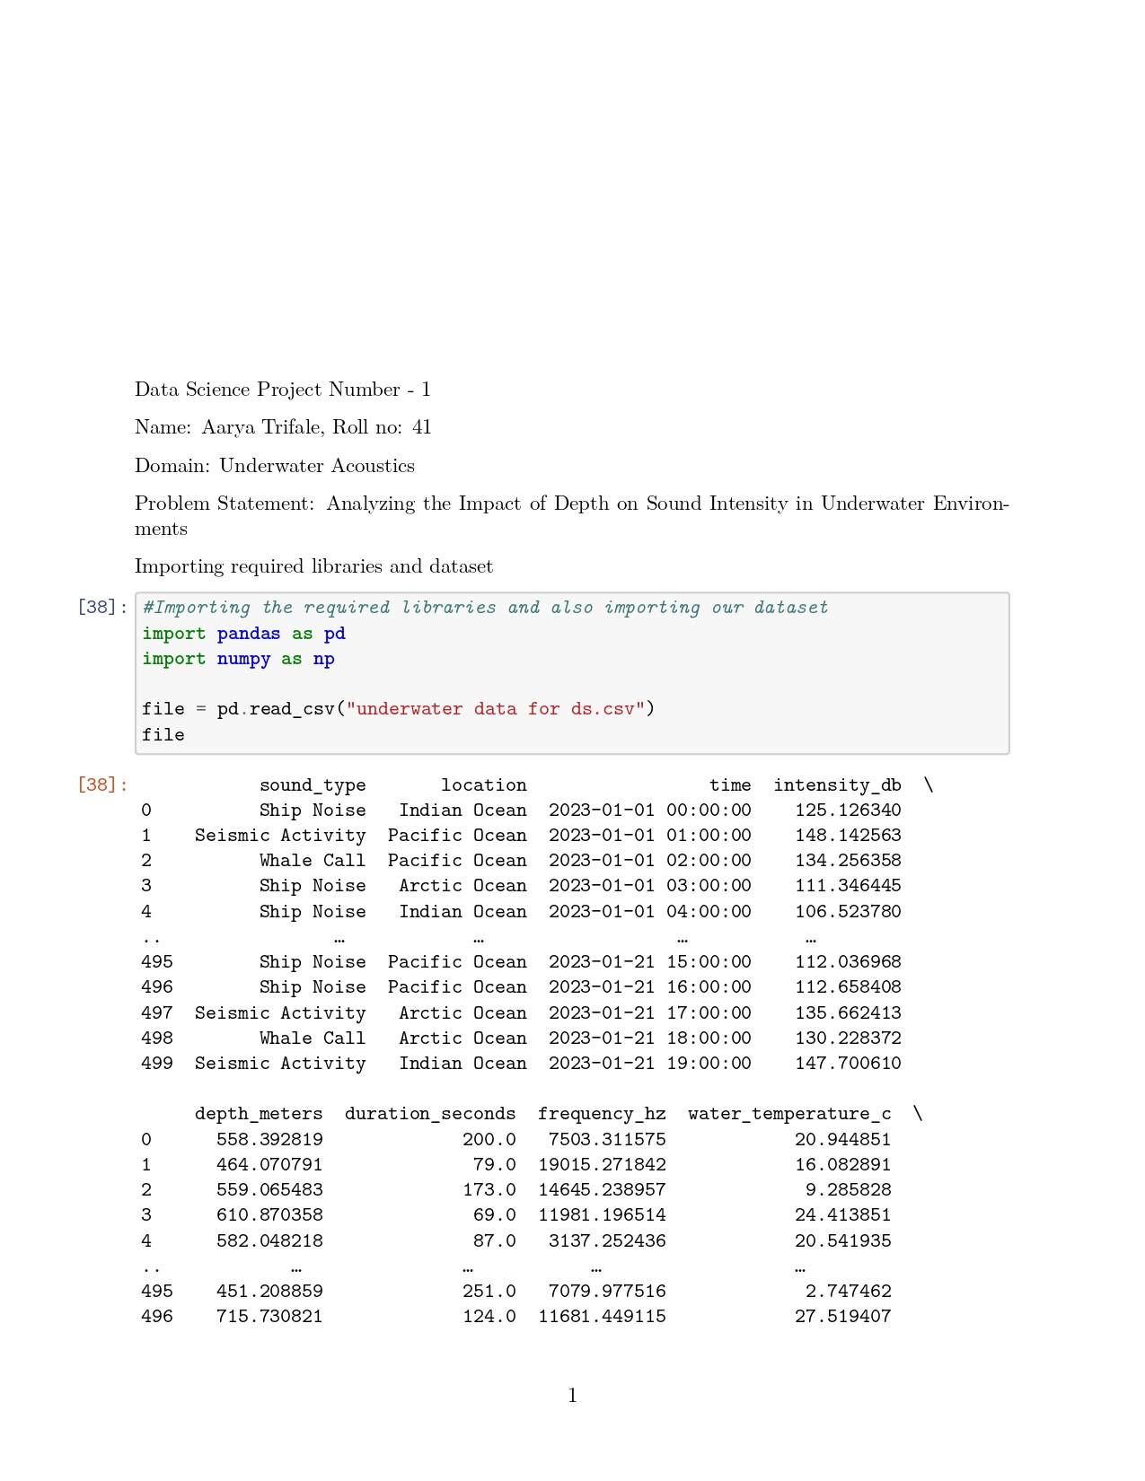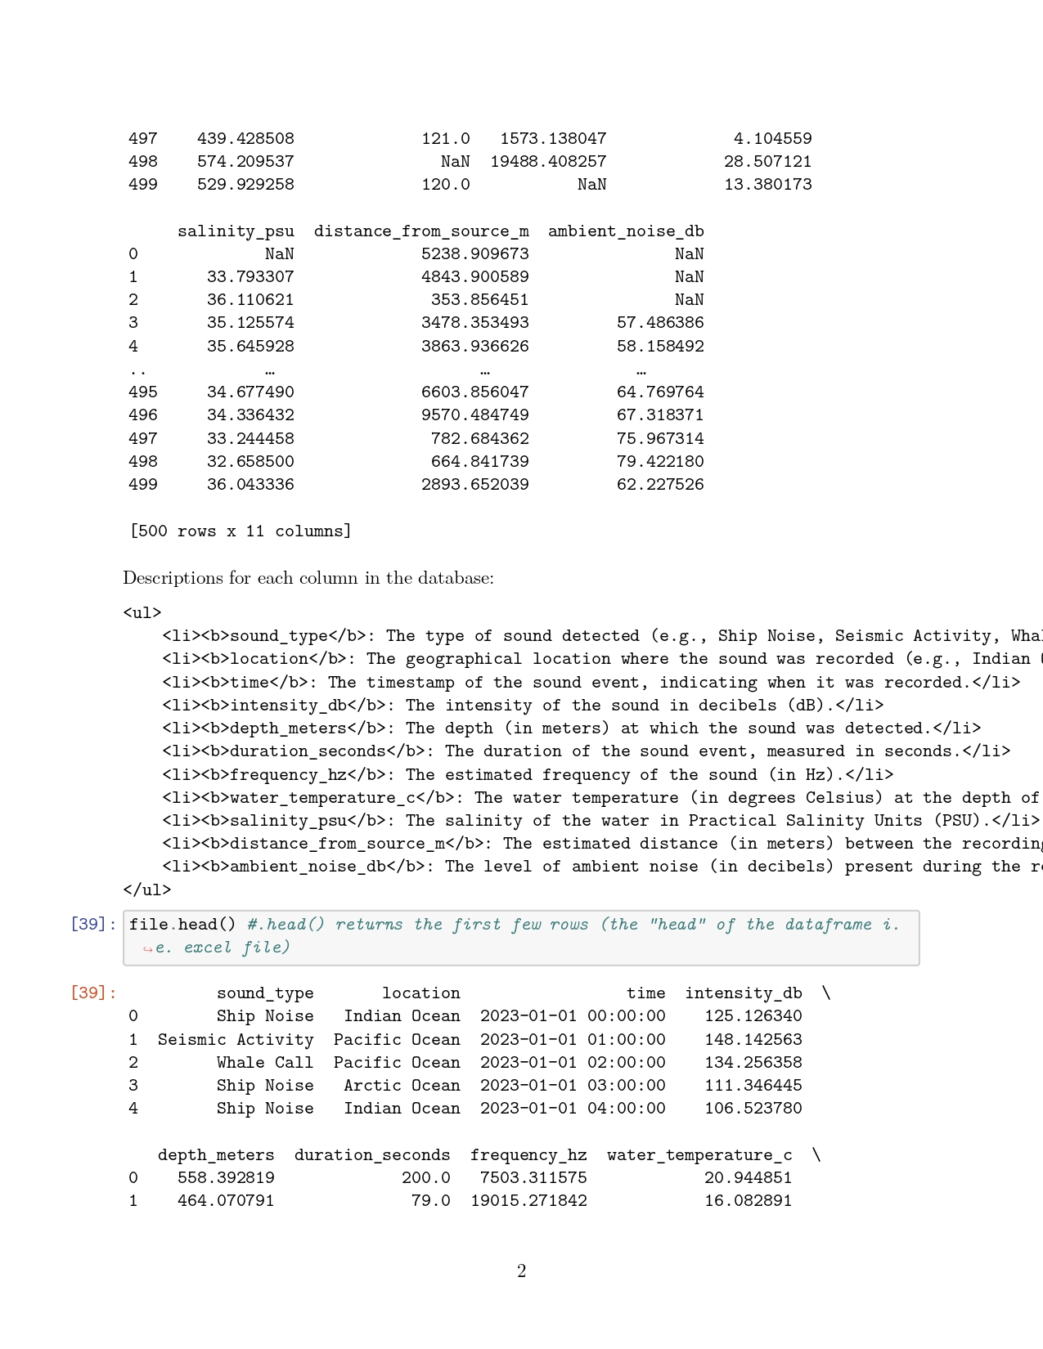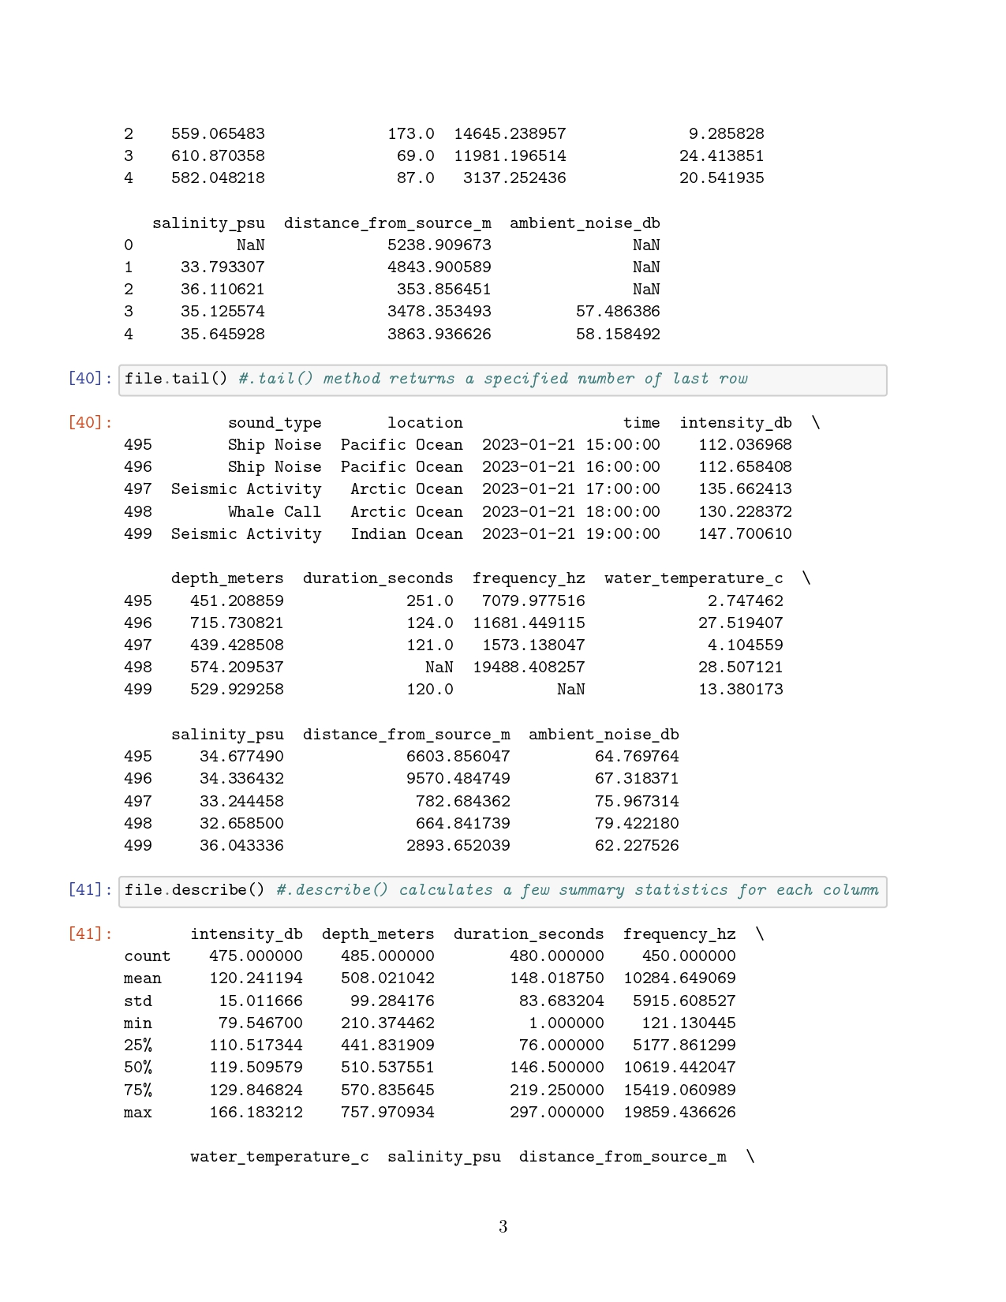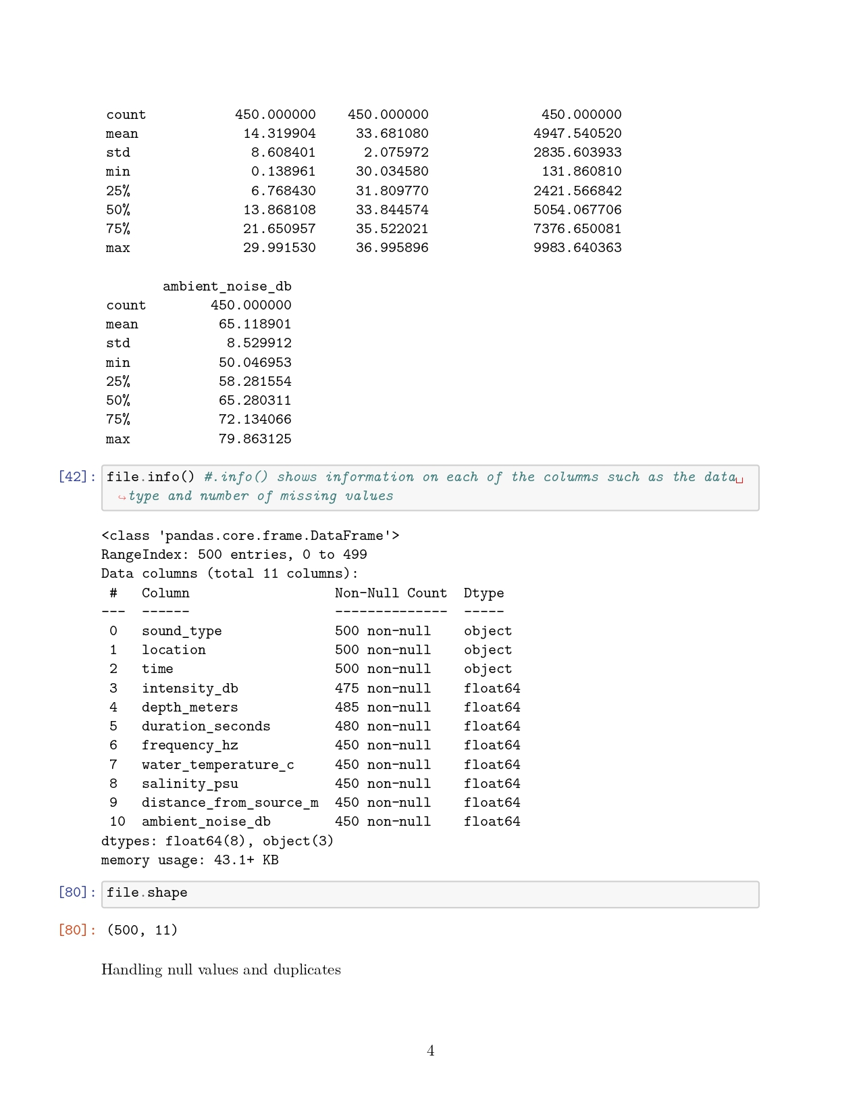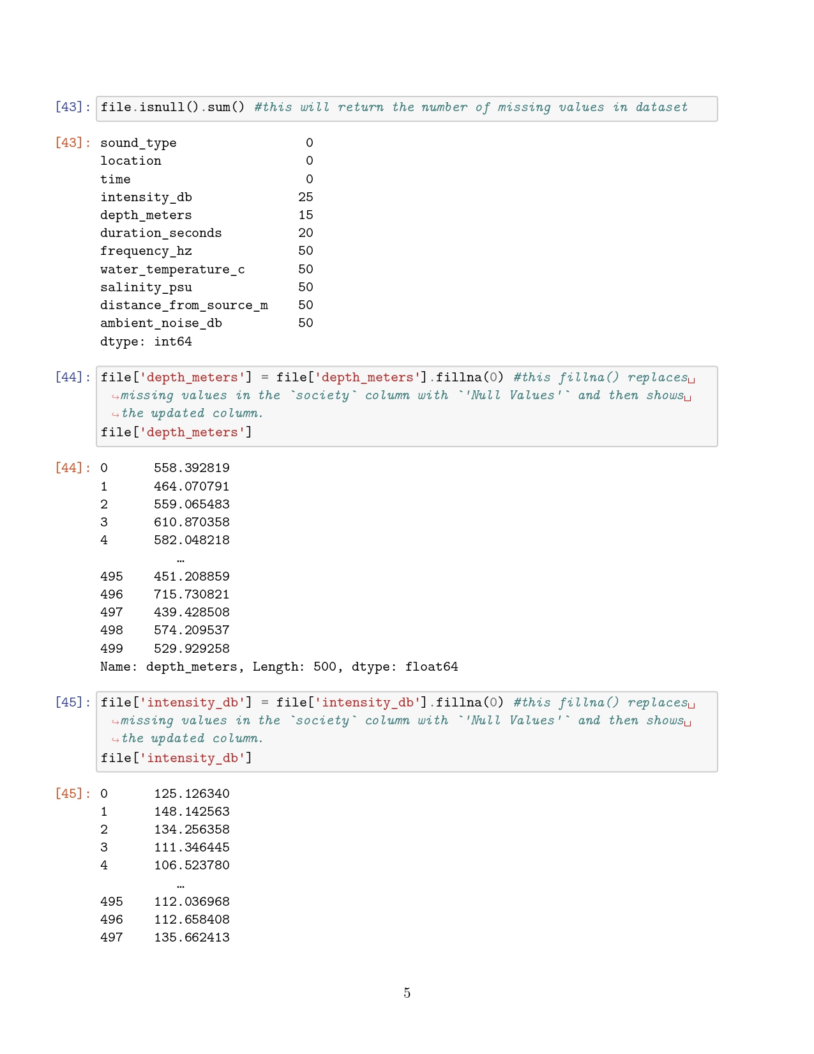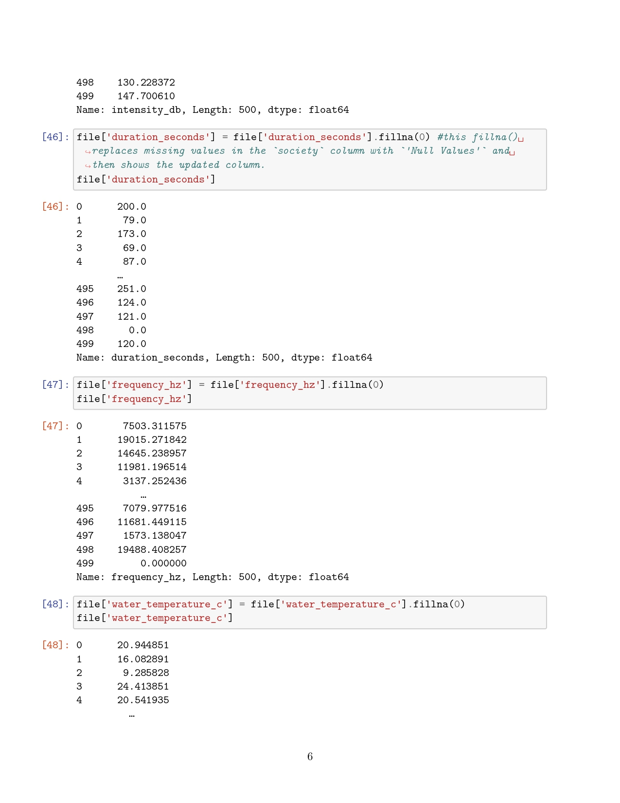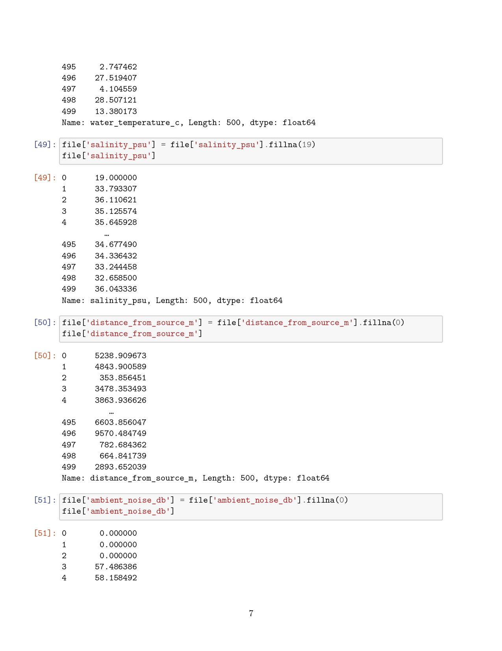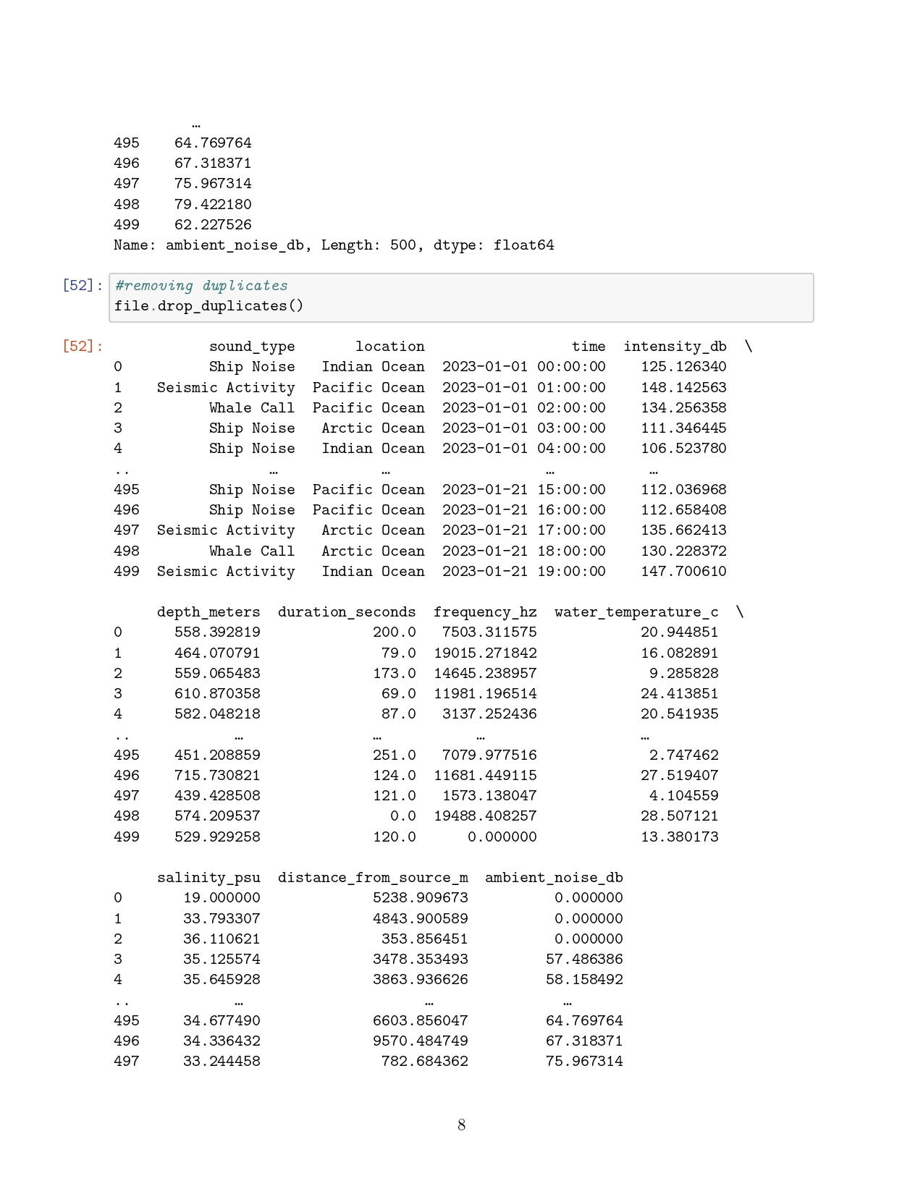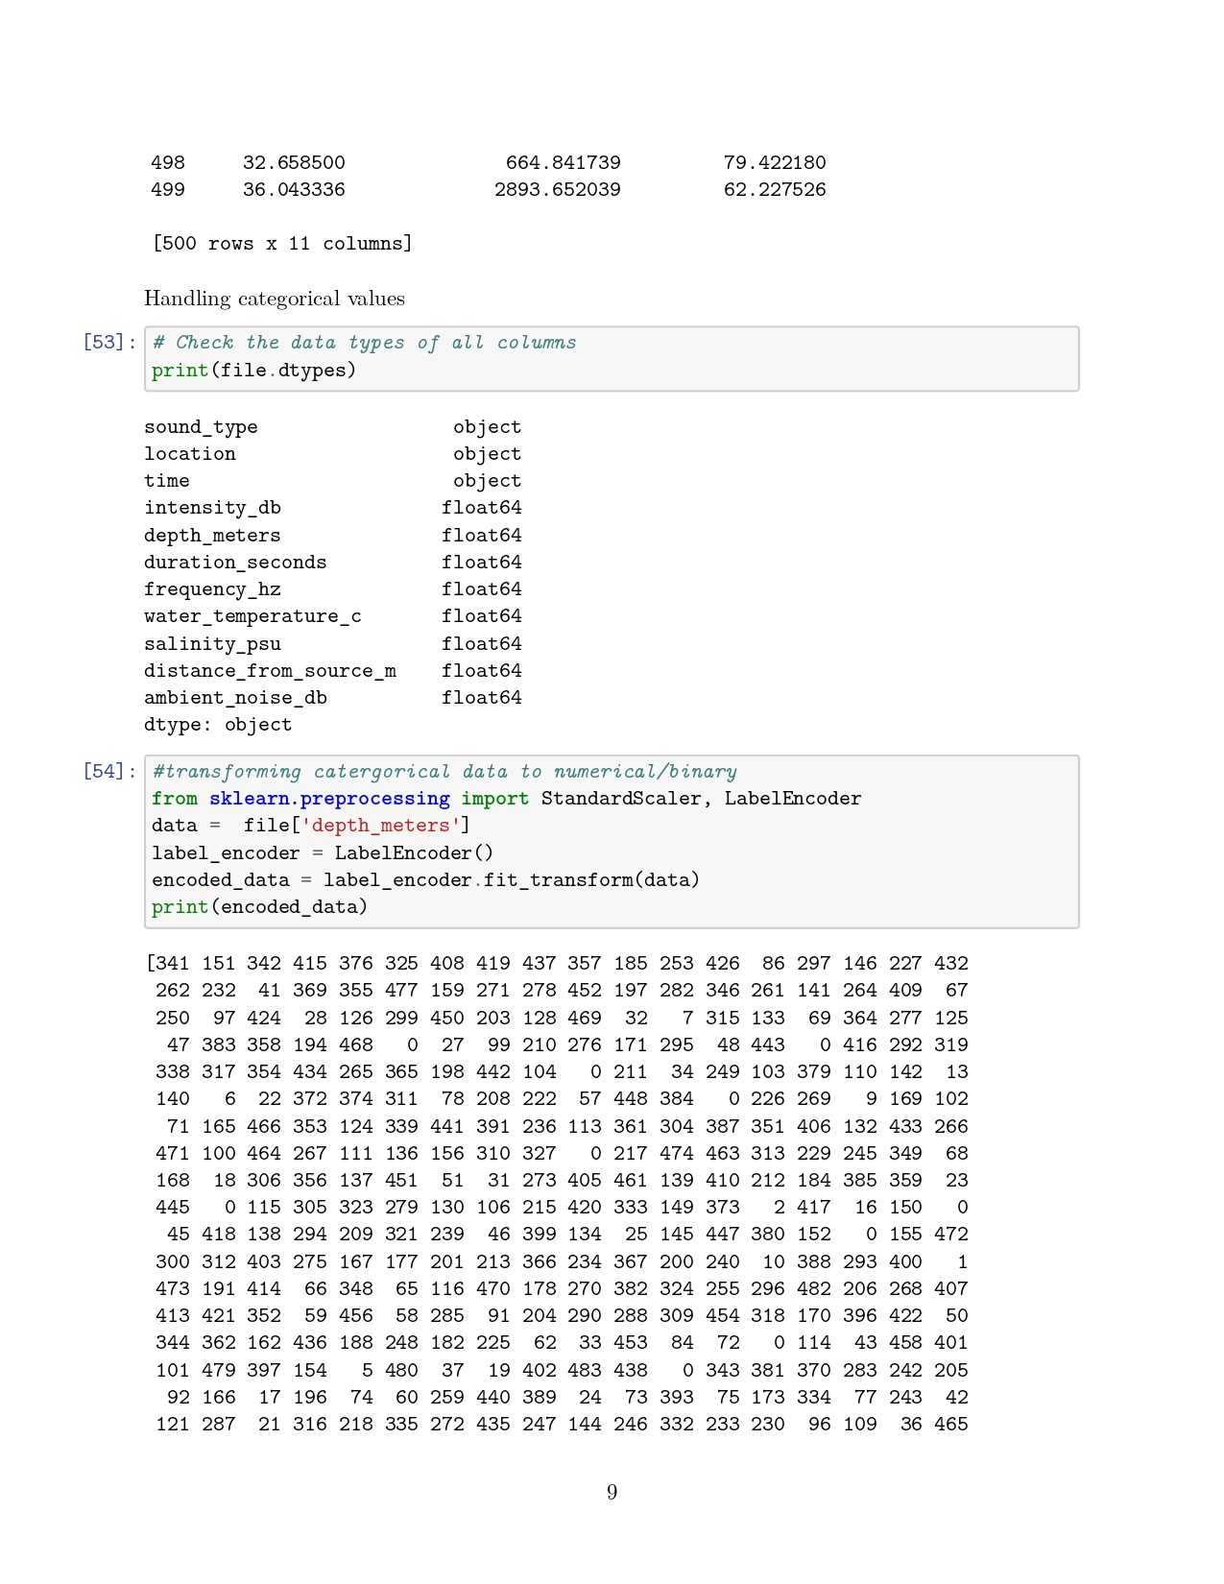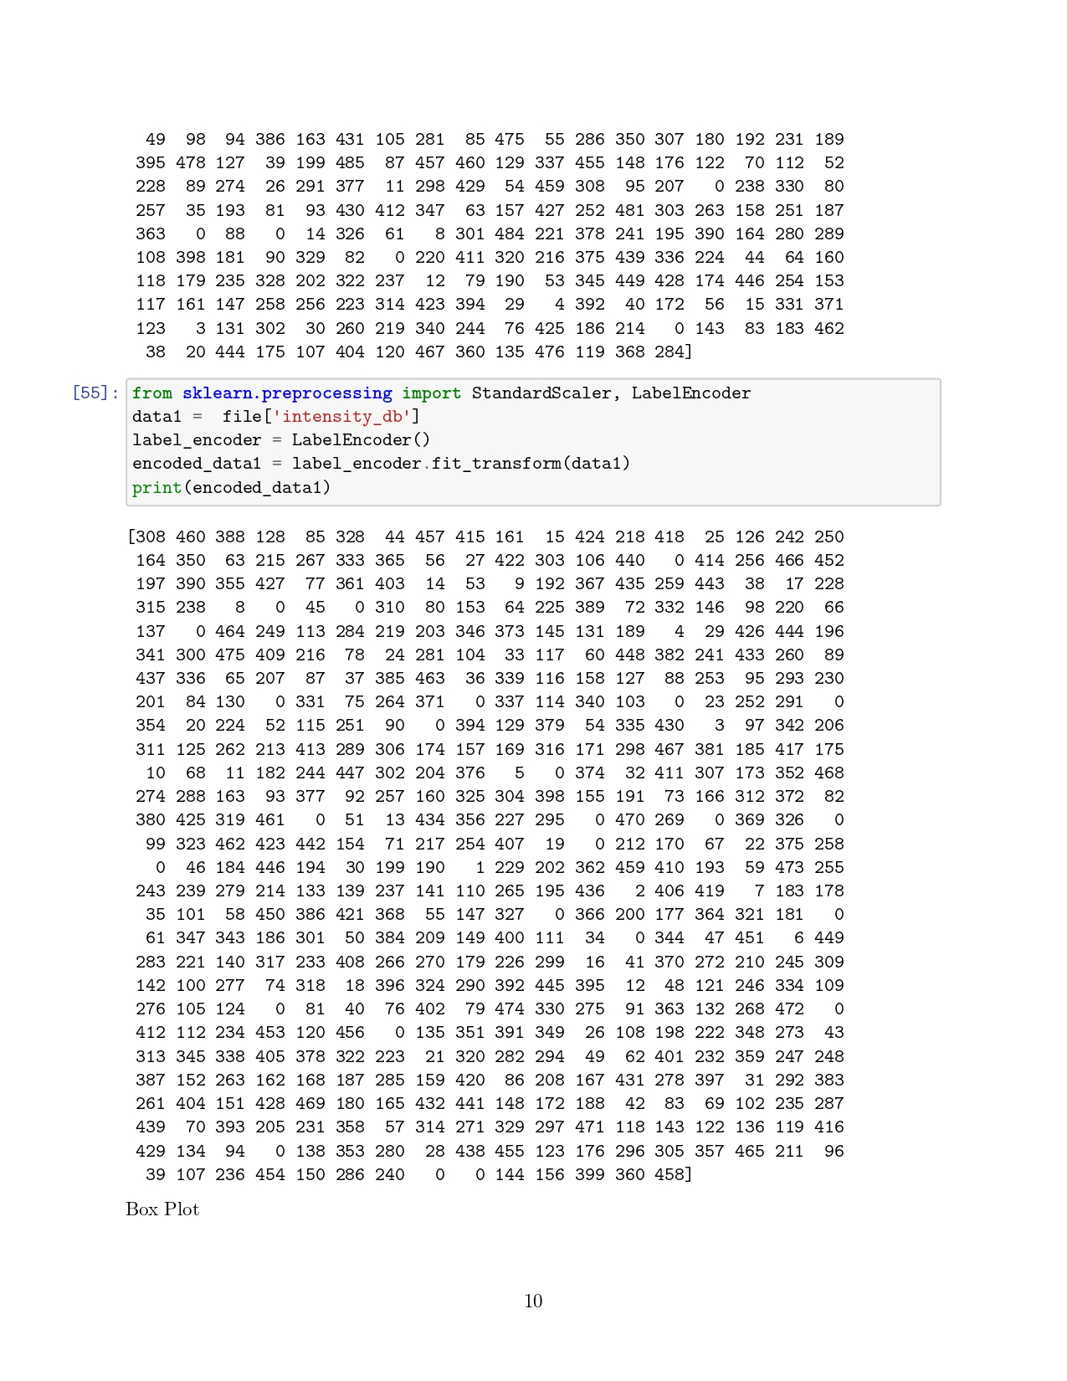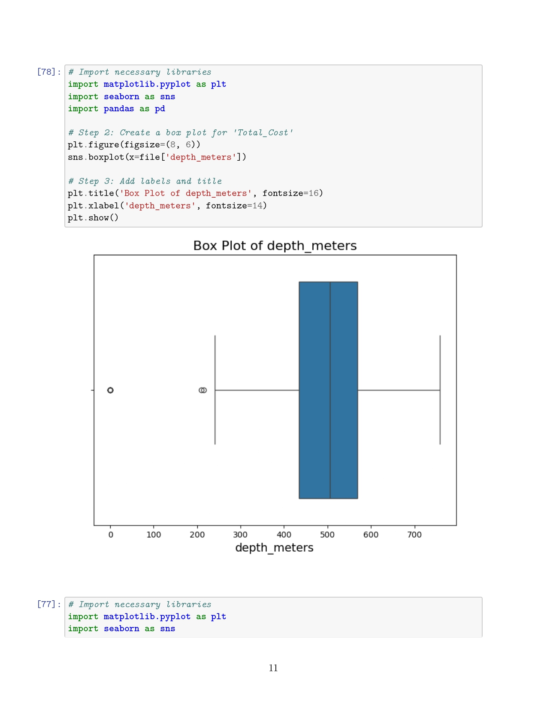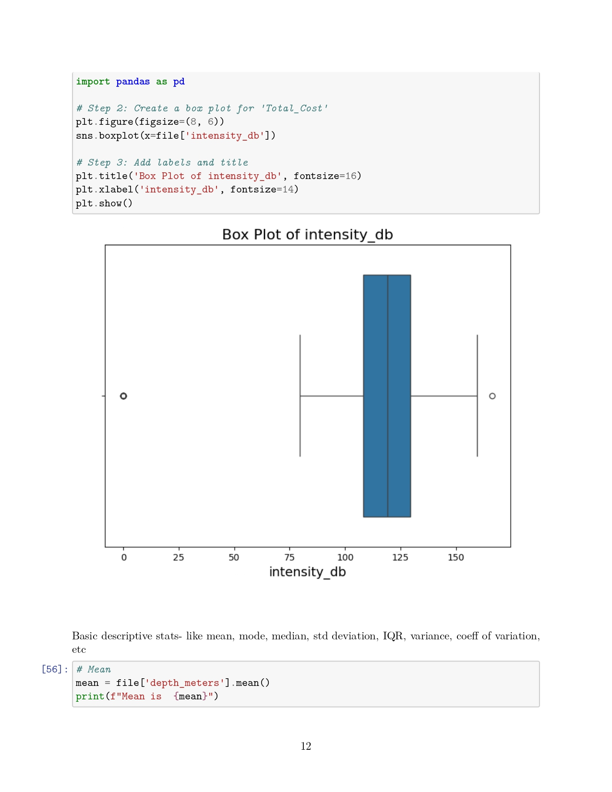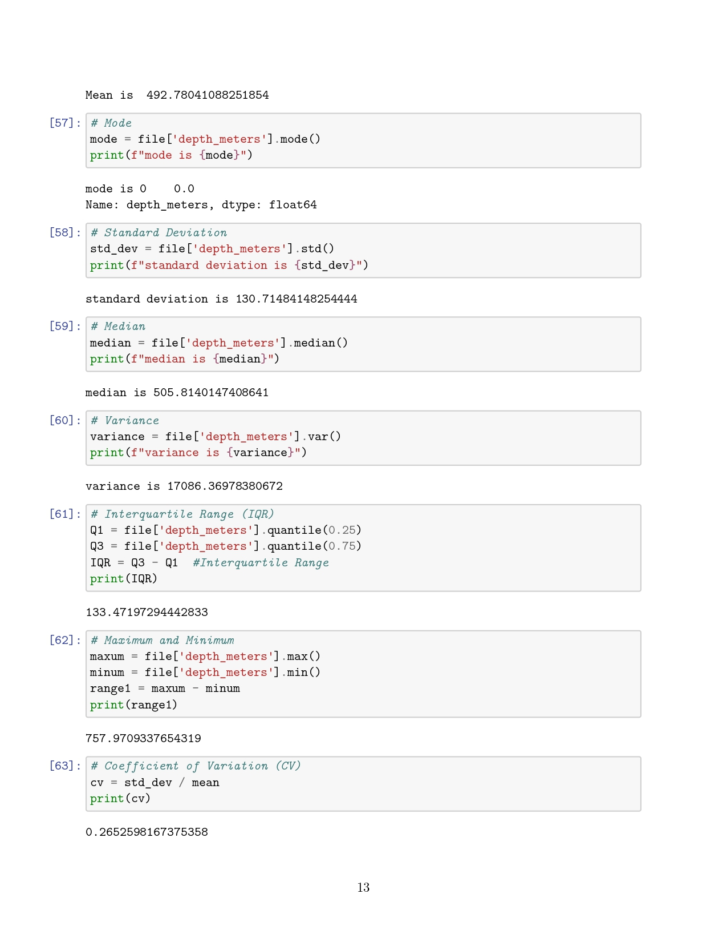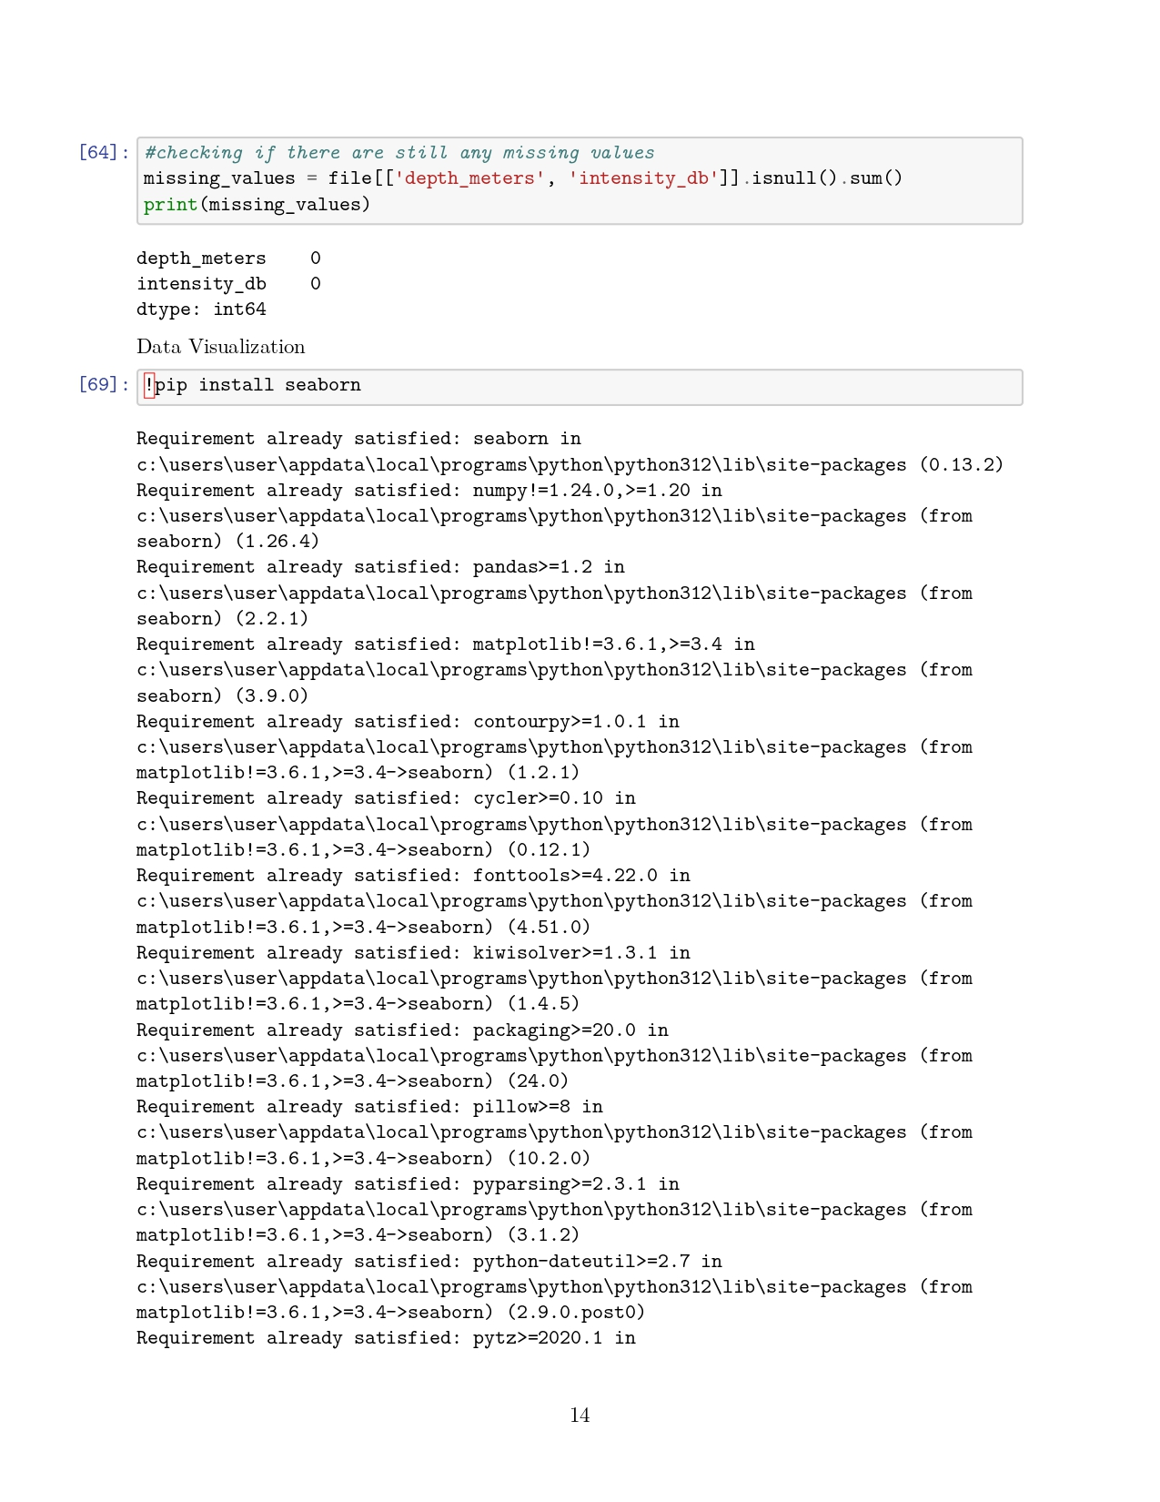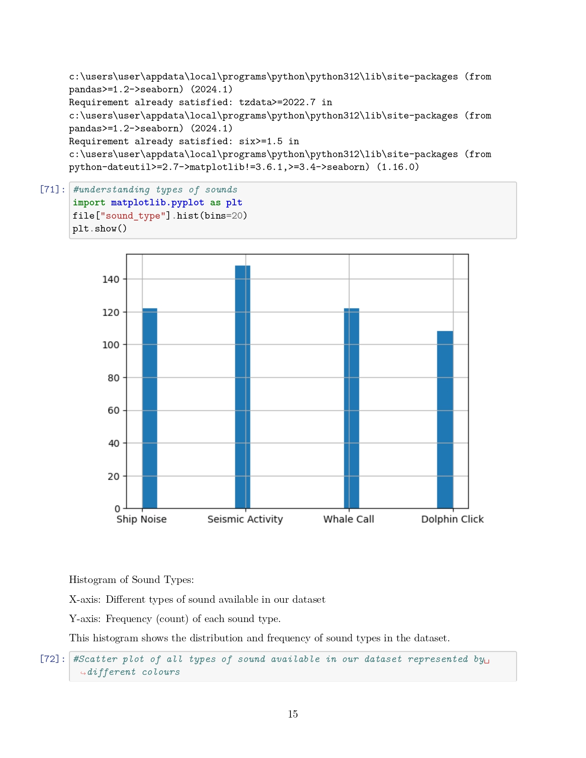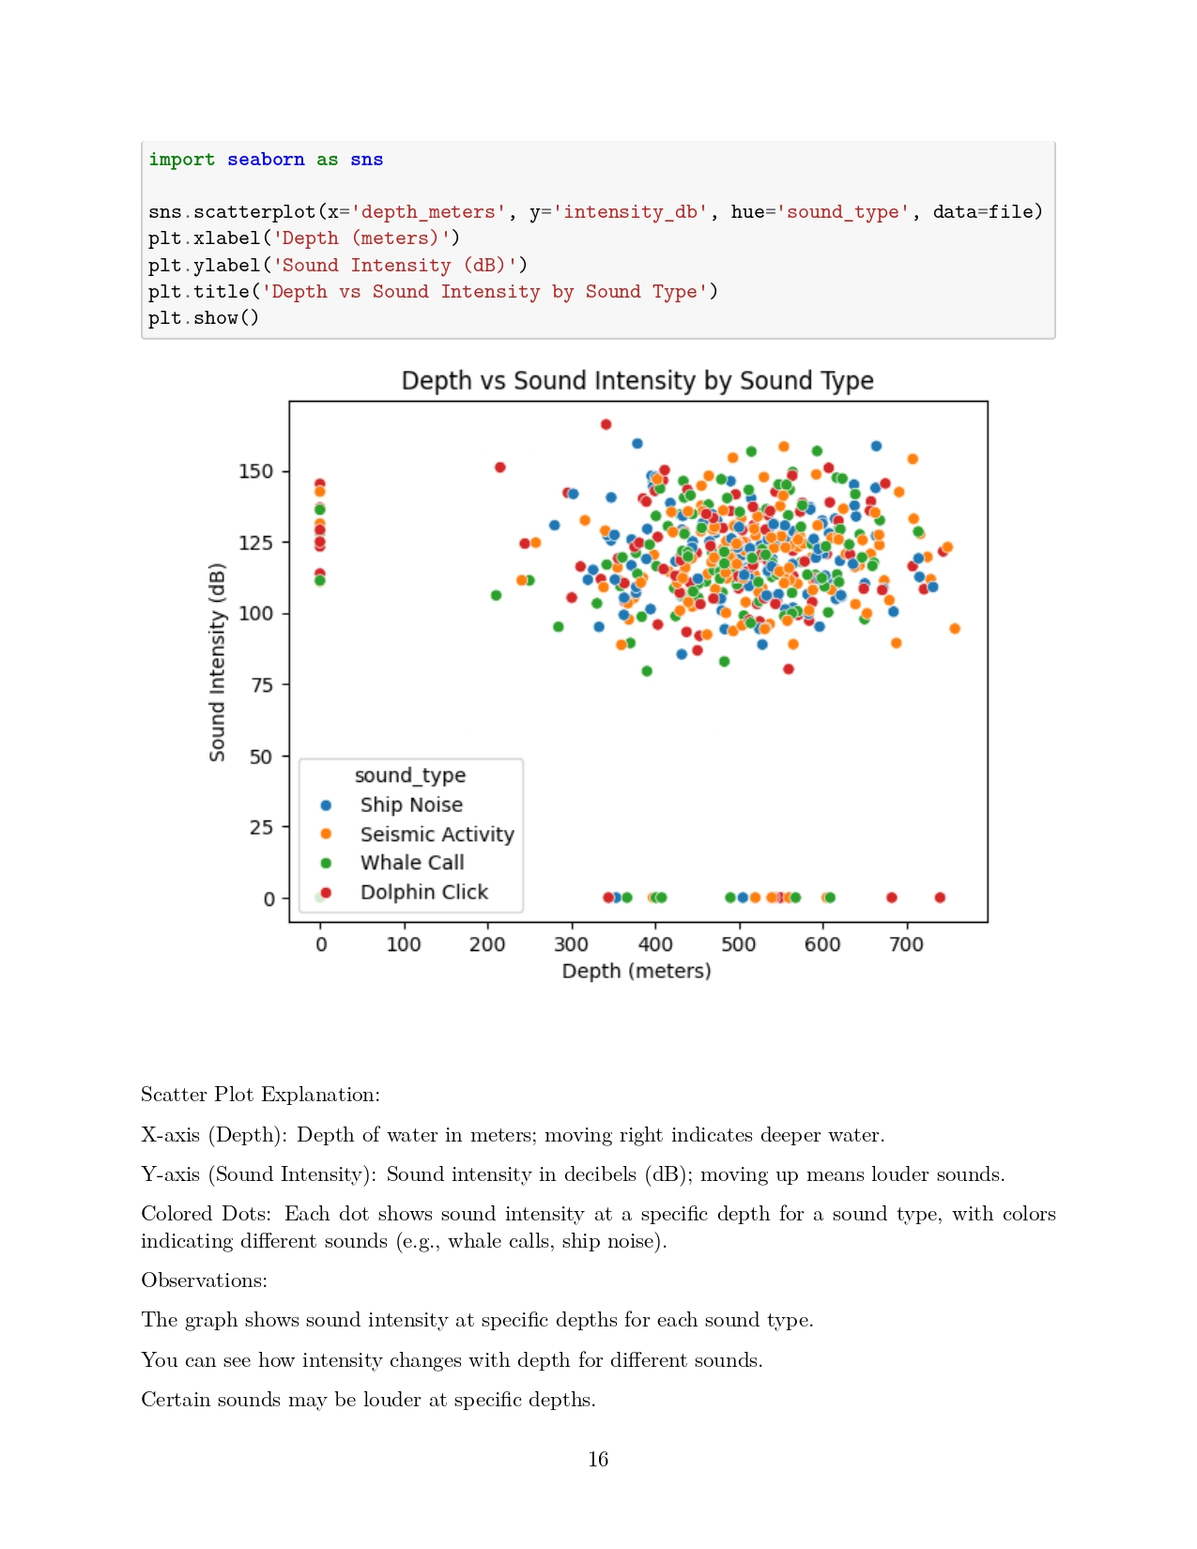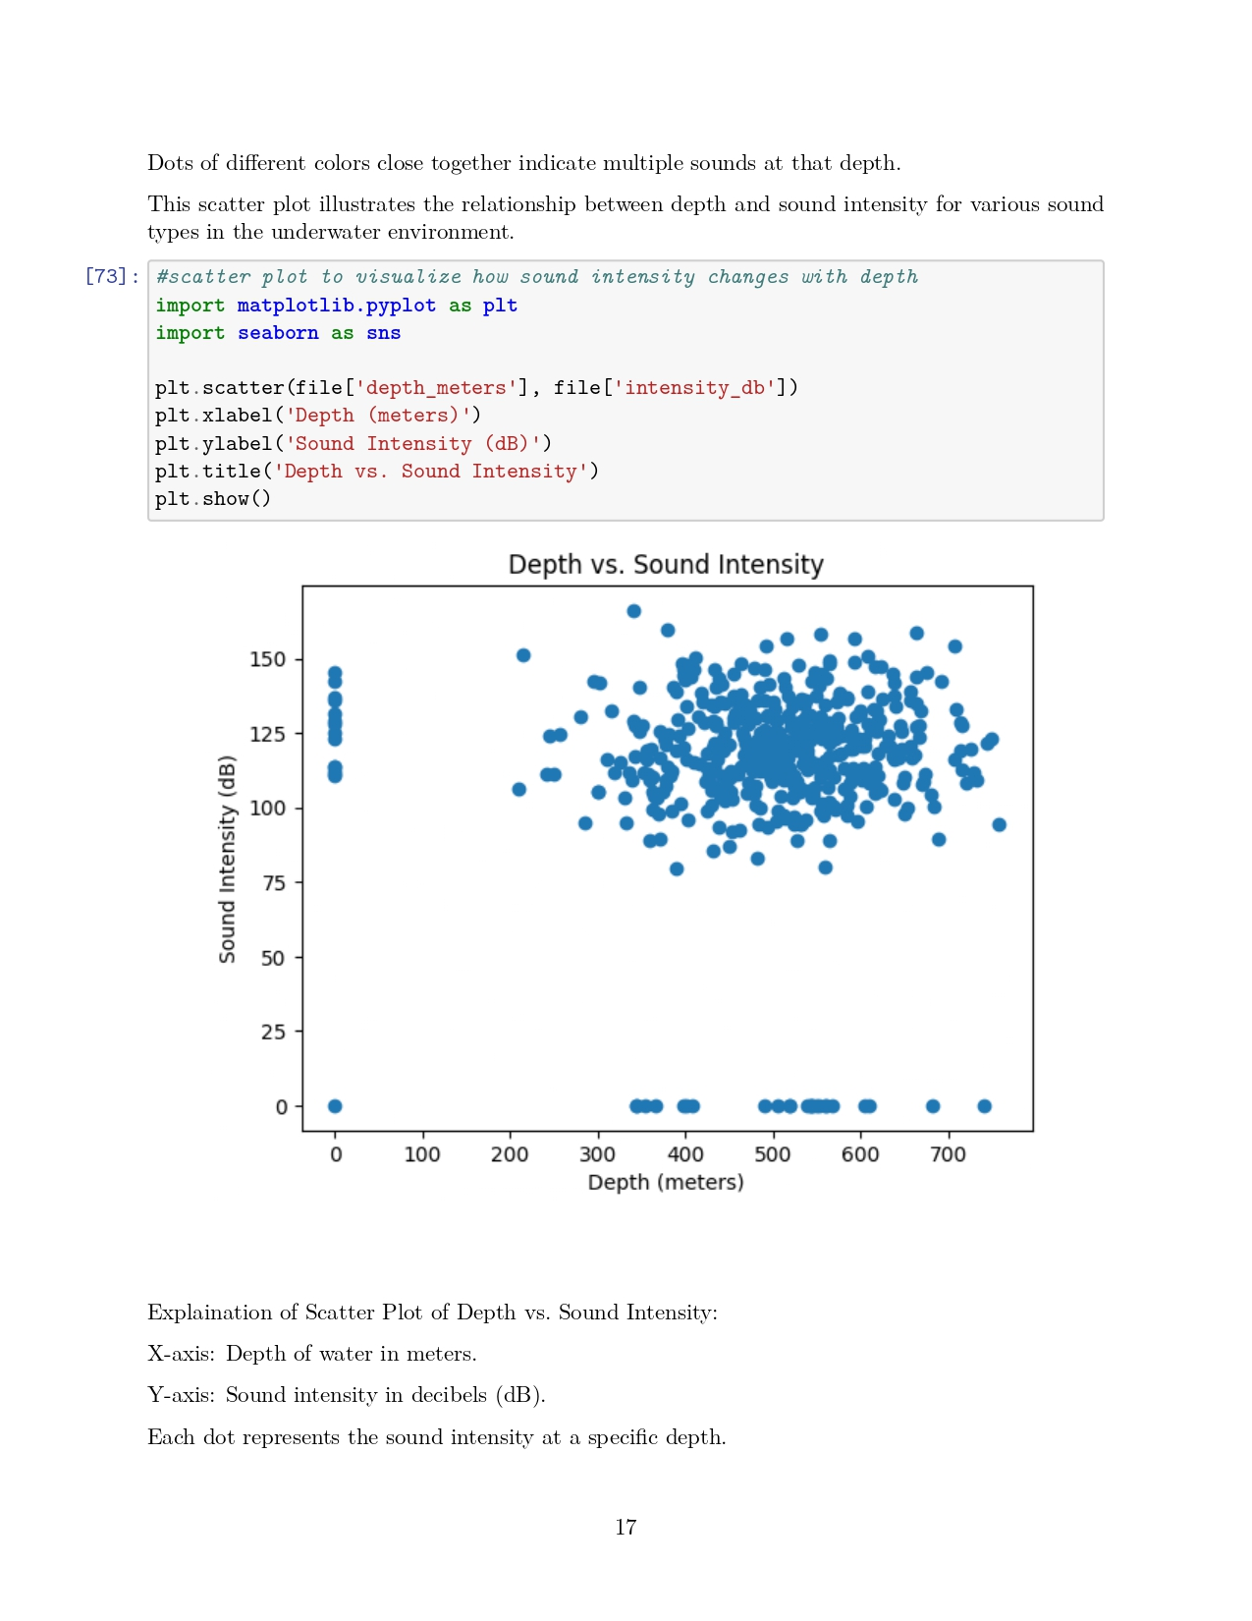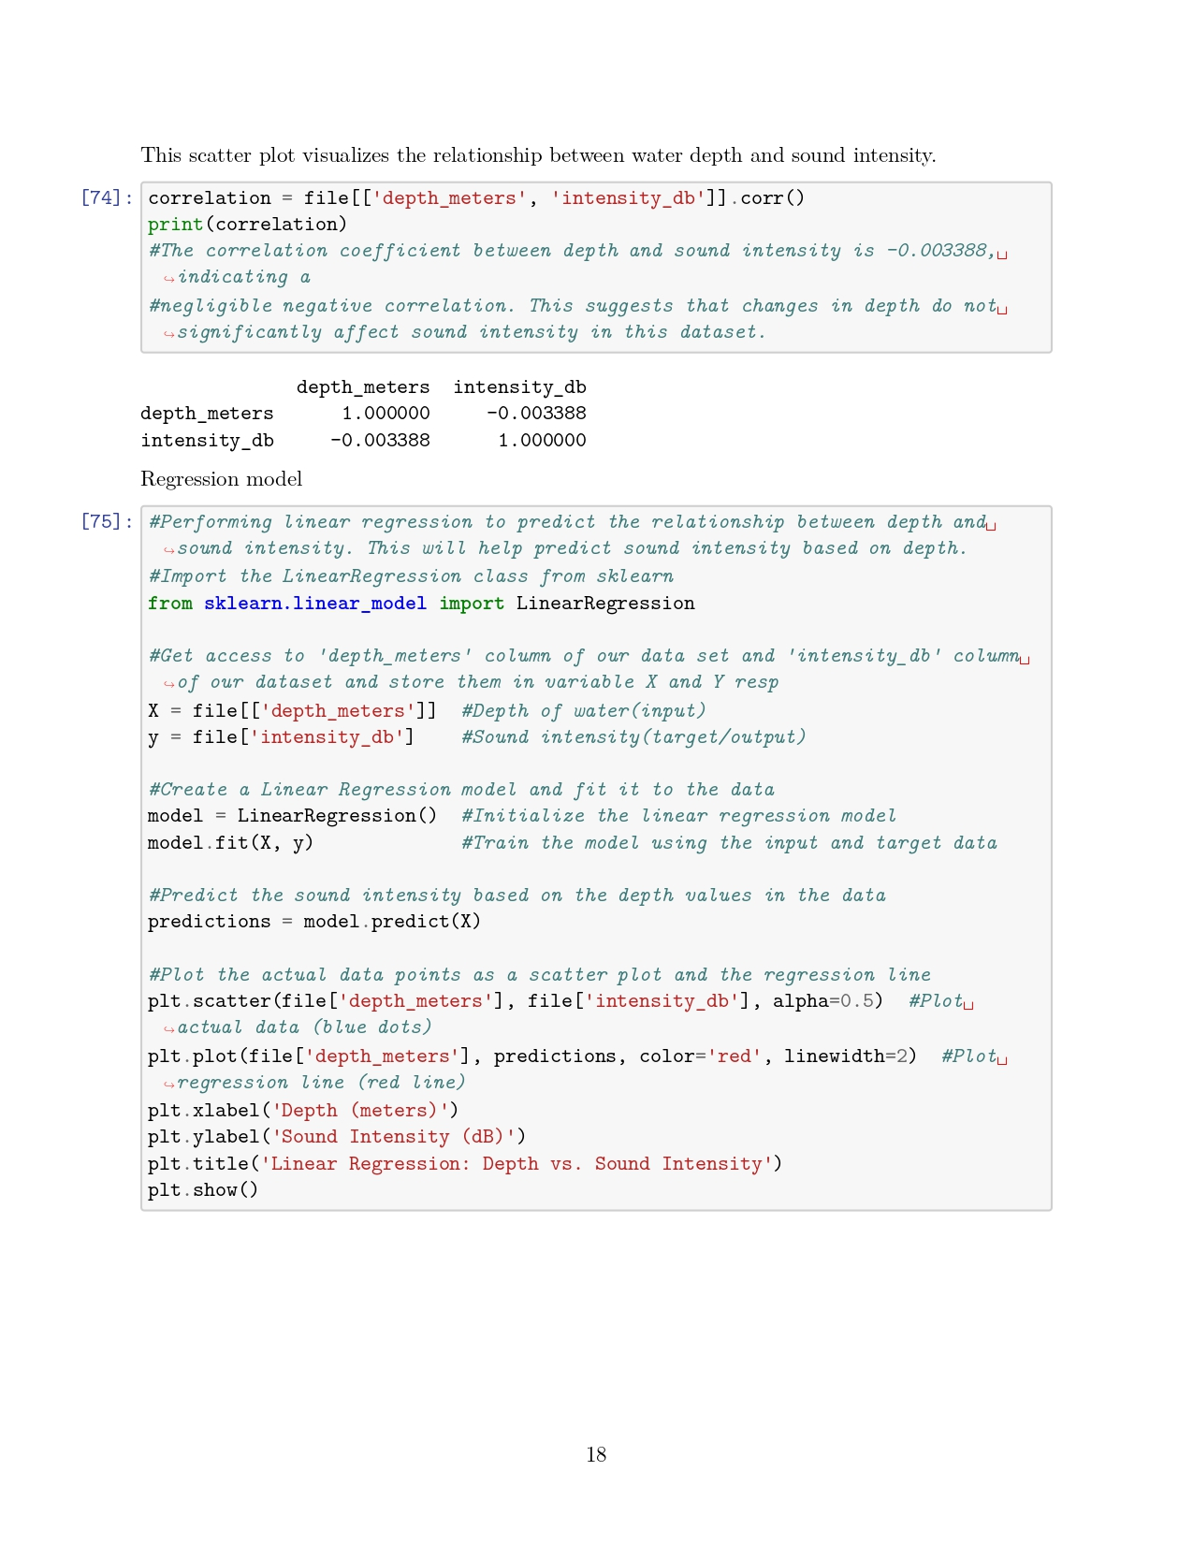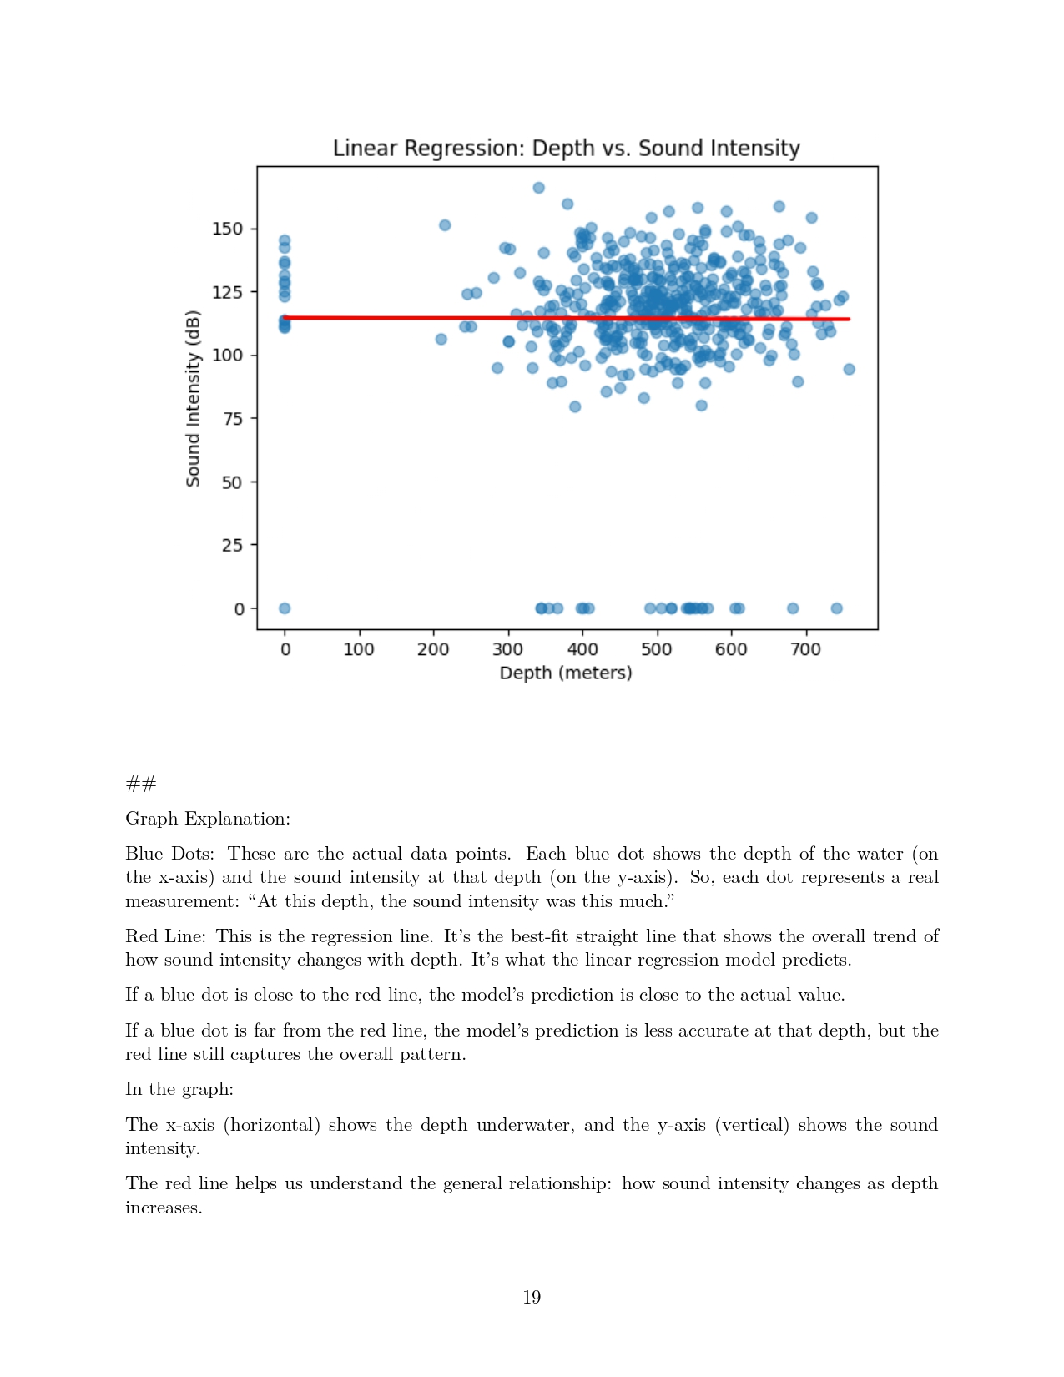

**Conclusion:**

In this project, I looked at how sound intensity changes with water depth using a dataset that included different types of sounds. I found that there is almost no relationship between depth and sound intensity, meaning that as depth changes, sound intensity does not change much.

The regression analysis helped me predict sound intensity based on depth, giving me a better understanding of how sound works underwater. The visualizations also showed how different sound types and their intensity levels vary at different depths.

Overall, this project helped me learn about the complexities of underwater sound and what factors can affect it. This understanding is important for studying marine environments and their sounds